Hypothetical Panzer Campaigns ; Game 1
Russia on Ice … September / October 1943 V 3.0
1/8
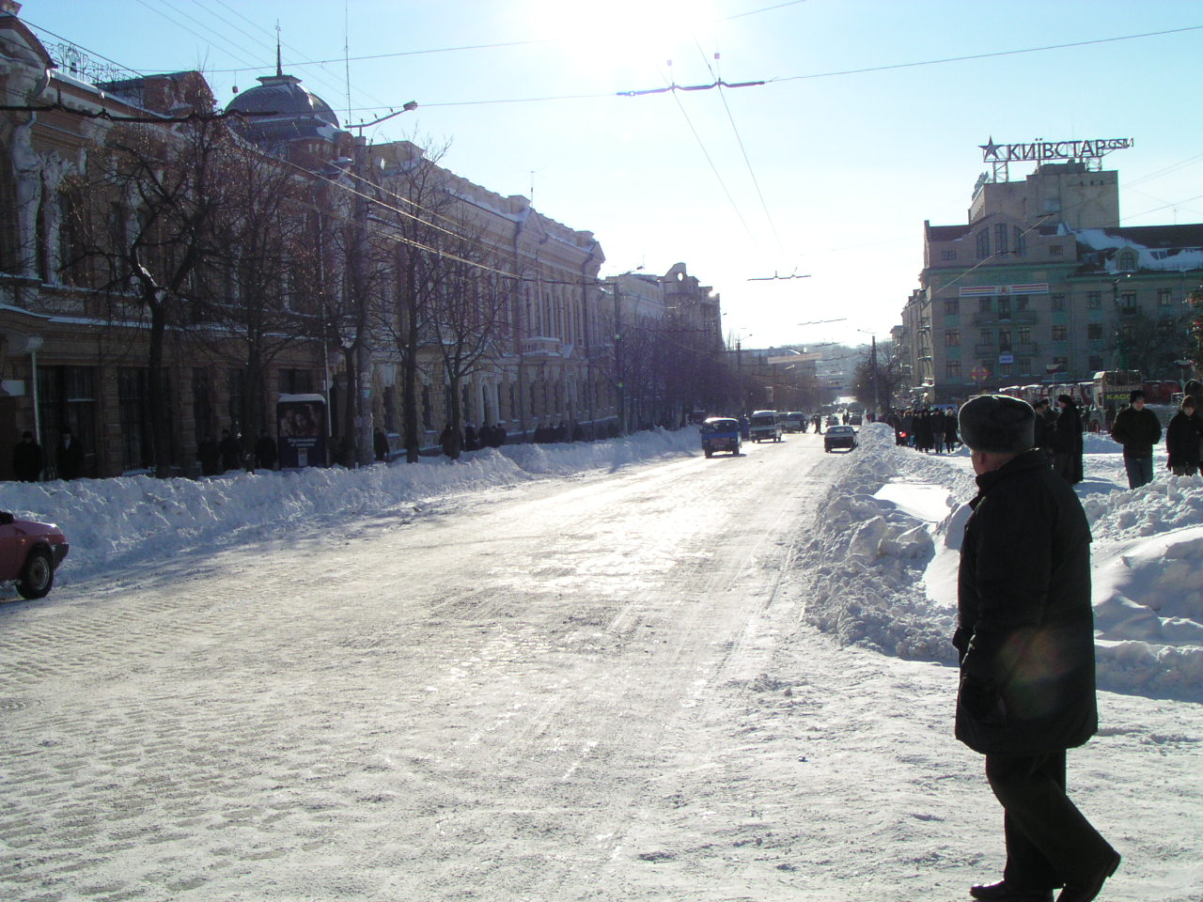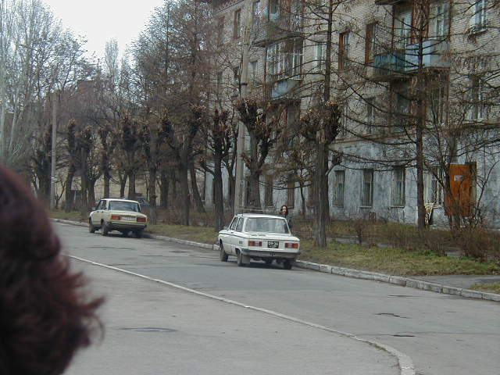
Modern Kirovograd 2002

HISTORICAL AND GAME NOTES VERSION 3.0

SUMMARY OF THE GAME
THE GAME USES THE FORCES IN GENERAL FROM THE K44 GAME (WITH TRUE THANKS TO THE ORIGINAL DESIGNERS); I WANTED THE FEEL OF A GERMAN AND SOVIET ARMY PRETTY MUCH IN BALANCE BOTH HAVE STRENGTHS AND WEAKNESSES. THE GAME IS DESIGNED TO OFFER PLAYERS TO EXPLORE PRETTY MUCH EVERY ASPECT OF THE GAME SERIES RULES TO DATE.
THERE ARE A LOT OF ACTIONS COVERED, A DOGGED DEFENCE LINE, A HEAVILY DEFENDED CITY, A FORTIFIED TOWN (THE GERMAN SUPPLY HUB), A PURSUIT TO THREE RIVER CROSSINGS COMBINED WITH AIRBORNE LANDINGS AND A POSSIBLE AIRLIFT OF KEY HQ PERSONNELL OUT OF A POCKET IF FORMED.
THE SOVIETS HAVE A CHANCE TO ENCIRLE MOST OF THE 8TH ARMY; THE GERMANS HAVE RESERVES OF GREAT AND DECISIVE POWER IF USED WELL. THERE IS AN ON MAP AIRFIELD WITH SPECIAL RULES; CONTROL (DENIYING THE AXIS ITS USE) OF THIS AIRFIELD WILL BE DECISIVE FOR THE SOVIETS.
THE GAME IS SPLIT INTO SEVERAL VICTORY SEGMENTS THAT NEED NOT END IN A TOTAL VICTORY FOR ONE SIDE OR THE OTHER.
ALL IN ALL I HAVE ATTEMPTED TO OFFER ALL TYPES OF COMBAT WITHIN A BELIEVABLE IF HYPOTHETICAL FRAME.

I ADVISE PLAYERS NOT TO EXAMINE THE OTHERSIDES FORCES PRIOR TO START OF PLAY … YOU WILL HAVE MORE OF A CHALLENGE THAT WAY. THIS IS A GAME TO EXPLORE MULTIPLE SKILLS IN ATTACK AND DEFENCE. THERE IS A MULTITUDE OF PROBLEMS TO SORT OUT FOR BOTH SIDES … IN THIS GAME THERE IS NO HINDSIGHT!!

HISTORICAL BACKGROUND TO THE SCENARIO
BAD WEATHER DELAYS THE ALLIED LANDINGS IN SICILY, HITLER PRESSES ON WITH THE KURSK OPERATION QGAINST ALL ADVICE AND THE GERMANS SIMPLY EXAUST THEMSELVES .THE SS LAH AND SS DR ARE ENCIRLED AND ANNHILATED .HIMMLER COMMITS SUICIDE, THE SS LOYALTY TO HITLER WAVERS FOR A MOMENT. THE ARMY SEIZE THE INITIATIVE AND HITLER IS MURDERED IN THE COUP.
THE ARMY RAPIDLY ORGANIZE A WITHDRAWL TO BETTER DEFENSIVE LINES BUT THE WEATHER BEFORE THE 20TH SEPTEMBER BOGS DOWN MOST OF THE 8TH ARMY INFANTRY FROM REACHING THE RIVER DNEPR IN GOOD TIME. THE 8TH ARMY IS DANGEROUSLEY POSITIONED AND THE RUSSIANS KNOW IT.
THEY RUSSIANS HAVE DECIDED TO PRESS ON IN PURSUIT BUT WITH LITTLE SUPPLY. IN THE SOUTH THE WELL ORGANIZED AND DUG IN 1ST PZ ARMY HAS BOUGHT THE RUSSSIANS TO A HALT AT KIROVOGRAD BUT THE AREA TO THE NORTH TO BE OCCUPIED BY PART OF THE 8TH ARMY IS STILL OPEN AND THE RUSSIANS SEIZE THE CHANCE TO BREACH THE GAP AND PUT A WEDGE BETWEEN

2/8
THE 1PZ ARMY AND 8TH ARMY. FURTHERMORE THEY WILL SUPPORT THE OPERATION WITH A LARGE AIRBOURNE LANDING BEFORE THE WEATHER CLOSES IN AGAIN …..
THE STAGE IS SET.

MAJOUR DATA CHANGES
WAGONS = DEFENSIVE VALUE REDUCED TO 10 (TO BETTER REPRESENT THE SLOW VULNERABLE NATURE OF THIS TYPE OF UNIT)
JU87 AND IL2 = DEFENCE RAISED TO 16 (TO REPRESENT THE METHOD OF ATTACK USED BY THESE AIRCRAFT MAKING THEM MORE DIFFICULT TO HIT
PARTISANS = SOME HAVE DECEPTION UNIT CAPABILITY

TERRAIN CHANGES
VILLAGES, WOODS AND TOWNS = ALL RAISED + 10%

MAIN WEAPONS AND DATA CHANGES
TIGER = NOW FLAGGED AS UNRELIABLE. MOST OF THIS FIGHTING WILL BE AT BEST ON SOFT GROUND CONDITIONS. I WOULD NOT HAVE MARKED IT AS UNELIABLE IN SUMMER OR HARD FREEZE CONDITIONS. RAISED THE DEFENCE VALUE TO 25. REDUCED ASSAULT TO 13
T34/76C = ( ALL ARMOUR WITH 76L GUN ) = REDUCED THE HARD ATTACK RANGE TO 1 HEX , THIS IS MAINLY AMENDED TO ALLOW BETTER REFLECTION OF THE RANGED FIRE AMENDMENT , THE T34 WILL STILL KILL BUT PANZERS WILL SEEK ENGAGEMENT AT LONGER RANGE WHERE POSSIBLE ( 2 HEX ) , THE T34 WILL SEEK TO ALWAYS CLOSE .
“OLIPHANTS” AND “HORNETS” = RAISED THE RANGE TO 3KM BASED ON THE KNOWN BALSITICS OF THE 88/L71 GUN. REDUCED ASSAULT VALUE TO 10. RAISED MORALE TO B( FOR THE OLIPHANTS.
RUSSIAN 5TH GUARDS CAVALRY CORPS = REGIMENTAL BREAKDOWN
THE RUSSIANS MADE PERHAPS THE BEST USE OF CAVALRY (MOBILE INFANTRY) IN WW2. THEY WERE ABLE TO OPERATE IN EXTENDED FORMATIONS, NEEDED LITTLE SUPPLY (NO FUEL IN PZC TERMS) AND ALTHOUGH LIGHTLY ARMED WERE ABLE TO SEIZE AND HOLD POSITIONS IN THE ENEMY LINE ONCE BREACHED AND COULD REMAIN FAIRLY MOBILE IN BAD WEATHER.
IN 1943 THESE USES WERE STILL BEING DEVELOPED. THE 5TH GUARD CAVALRY CORP HAS ITS MORALE RAISED TO B AND HAS REGIMENTAL BREAKDOWN TO FOUR SQUADRONS PER REGIMENT.

ARTILLERY
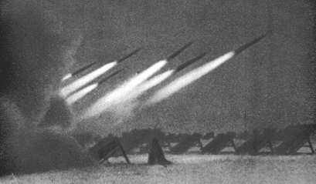
TO ENCOURAGE MORE REALISTIC AND INTERESTING USE I AMENDED THE ARTILLERY RULES SLIGHTLY AS FOLLOWS;
= REDUCED THE SET UP % VERY SLIGHTLY; -10% FOR BOTH SIDES
= INTRODUCED STOCKPILING 10% FOR THE RUSSIANS AND 5 % FOR THE GERMANS
= STOCKPILING FIRE 175% FOR THE RUSSIANS AND 150% FOR THE GERMANS

3/8
RANGED FIRE VALUE
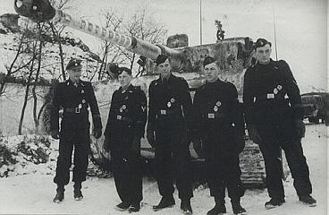

TO BETTER REPRESENT GERMAN SUPERIORITY IN HIGHER VELOCITY TANK (AND AT GUNS), OPTICS AND TACTICS, I HAVE MPROVED THE RANGED FIRE FROM 1/3 EFFECTIVENESS TO ½ EFFECTIVENESS.
THIS IS NOT TO ALLOW A UN REALSITIC BIAS BUT ALLOWS FOR BETTER CONSIDERATION OF HIGHER VELOCITY GUNS, OPTICS AND TACTICS OF LONGER RANGE ENGAGEMENT.

NOTE; ALL AT GUNS WITH A RANGE OF 2 KEEP THAT (INCLUDING THE SOVIET) TO GIVE THEM SOME ADVANTAGE TO SIMULATE SURPRISE
ALL DIRECT FIRE INFANTRY WILL ALSO BE MORE EFFECTIVE BUT NOTE THE IMPROVED TERRAIN EFFECTS WILL DAMPEN THAT OFF.

IF YOU DO NT AGREE WITH THESE VALUES …CHANGE THEM BACK IF YOU AND YOUR OPPONENT BOTH AGREE!!

HOUSE RULES; THE GERMAN AIRFIELD AT NOVO-VASILOV
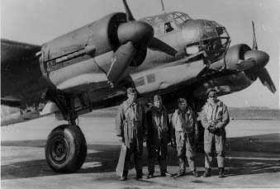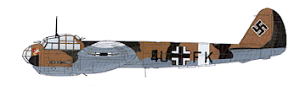

THE AIRFIELD ( THE AIRFIELD AT NOVO-VASILOV 96-66 IS A MAJOR AIR BASE , THE DISORGANIZED RETREAT OF THE 8TH ARMY HAS NOT ALLOWED TIME FOR ITS FULL EVACUATION AND THE GROWING CRISIS CONTINUES ITS USE …WITH RISK ) . NOTE I USED THE VILLAGE HEX TO ALLOW THE SIMULATION FOR BOMBARDMENT AND DAMAGE TO THE AIRFIELD.

A. IF THE AIRFIELD HEX IS RUBBLED IT BECOMES UNAIVAILABLE AND MAY NOT BE USED, THE GERMAN PLAYER THEN AGREES NOT TO USE AIRCRAFT BELONGING TO JG.1 AND KG.30
B. IF THE AIRFIELD HEX IS OCCUPIED THE ABOVE ALSO APPLIES AND EVEN IF RE OCCUPIED CANNOT AGAIN FLY THE ABOVE

4/8
C. SUPPLY AIRDROPS MAY CONTINUE TO BE MADE; THESE HOWEVER NOTE ARRIVE AT THE AIRFIELD OR ADJACENT HEXES.
D. IF THE HEX IS RUBBLED BUT CLEARED (BUT HAS NOT BEEN OCCUPIED) THEN THE GERMAN PLAYER MAY RESUME USE OF ONE UNIT IF AVAILABLE FOR THESE TWO AIRGROUPS PER TURN

HOUSE RULES FOR THE GERMANS

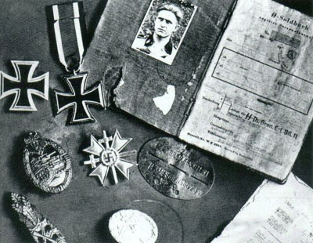

EVACUATION OF KEY PERSONNEL, 8TH ARMY HQ
ON A DAWN TURN IF THE 8TH ARMY HQ IS ON THE AIRFIELD (THE AIRFIELD MUST NOT BE RUBBLED BUT CAN BE RUBBLED AND CLEARED STATUS) AND THE WEATHER IS NOT STORM THE GERMAN PLAYER MAY DECLARE (TO THE RUSSIAN PLAYER) EVACUATION OF KEY PERSONNELL FROM THE HQ.
IF HE DOES THIS AND THE HQ IS NOT BROKEN AND STILL ON THE AIRFIELD HEX AT THE DUSK TURN OF THE SAME DAY A 0.5 POINT NOT 1.5 POINTS AS USUAL IS ADDED TO THE SOVIET VP TALLY WHEN THE WAY POINT IS REACHED IF AND WHEN THE HQ IS ELIMINATED. CORPS HQ OF THE 8TH ARMY (11TH AND 47TH PANZER BECOME 0 VP UNLESS ELIMINATED BEFORE THE AIRLIFT)
IF THE GERMANS MANAGE THIS AIRLIFT THE GERMAN PLAYER FORGOES A MAJOR VICTORY (ANY MAJOR VICTORY RESULT BECOMES A MINOR)

THE PANZER RESERVE
"If the tanks succeed, then victory follows.” Guderian, 1937.
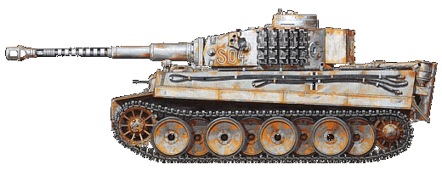

THE FOLLOWING RULES ARE TO SIMULATE BEURACRATIC AND A LITTLE CONFUSED RELEASE OF RESERVE BUT REFITTING UNITS FOR COMBAT.
THE FOLLOWING PZ DIVISIONS ARE THE RESERVE BUT MOST HAVE BEEN STRIPPED OF THEIR ARMOUR TO BRING THE FRONT LINE UNITS UP TO STRENGTH (AFTER KURSK) AND ARE BEING HURIDLY REFITTED. THE GERMAN PLAYER MAY ONLY MOVE THESE UNITS AS FOLLOWS;

GROSS DEUTCHLAND, 5TH SS WIKING***, 24TH PANZER, 1st PANZER

5/8
ON TURN 25 CHOOSE ONE OF THE FOLLOWING;
OPTION 1
TURN 25 RELEASE ONE DIVISION
TURN 40 RELEASE ONE DIVISION
TURN 50 RELEASE ONE DIVISION
TURN 90 ALL UNITS MAY MOVE
CORPS UNITS AND THE CORPS / ARMY RESERVE HQ MAY MOVE WHEN THE LAST DIVISION OF THE CORPS IS RELEASED. THIS RULE DOES NOT APPLY TO THE 3RD PANZER CORPS

OPTION 2
TURN 35 RELEASE TWO DIVISIONS
TURN 60 RELEASE ONE DIVISION
TURN 100 ALL UNITS FREE

CORPS UNITS AND THE CORPS HQ MAY MOVE WHEN THE LAST DIVISION OF THE CORPS IS RELEASED. IF ANY UNIT OF AN UNCOMITTED DIVISION IS ATTACKED THE DIVISION IS RELEASED (AND THE RUSSIAN PLAYER NOTIFIED)

*** 5TH SS WIKING IS ALSO RELEASED ( THREE TURNS LATER ) IF ANY GERMAN GROUND UNIT OF 8TH ARMY SPOTS A SOVIET PONTOON BRIDGE ON THE DNEPR OR A SOVIET UNIT IS SPOTTED IN ANY PURE BRIDGE HEX ON THE DNEPR OR A TOWN OR VILLAGE HEX OF KANEV OR CHERKASSY ( BOTH PLAYERS MUST AGREE THE BRIDGE IS SPOTTED). PARTISANS, PARATROOPS AND DECEPTION PARTISANS DO NOT COUNT FOR THIS RULE

VICTORY CONDITIONS

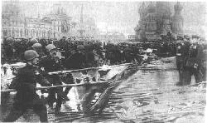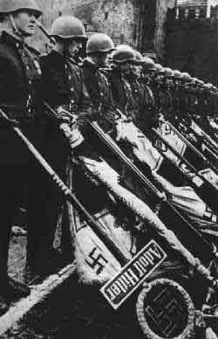

THERE ARE 19 VICTORY (19 X 1 VP) LOCATIONS ( NOTE NONE IN THE RUSSIAN REAR , I DID NOT WANT POINTLESS PANZER ATTACKS TO THE RUSSIAN REAR , THOUGH OF COARSE CUTTING OFF RUSSIAN TROOPS IS STILL A GOOD REASON TO DO SO ) . AT EACH WAY POINT CONTROL OF THESE POINTS IS EVALUATED (1/2 PTS ARE ROUNDED DOWN…SEE IMPORTANT NOTE ON AIRLIFT OF 8TH ARMY HQ) FOR A RUSSIAN VICTORY AS BELOW. THE RUSSIAN PLAYER MAY DECLINE A MINOR VICTORY AND CARRY ON TO TRY FOR THE NEXT WAY POINT. THE GERMANS MAY DECLINE A MINOR VICTORY AS WELL).

6/8
TURN 50 = 5 VP MAJOR 3 VP MINOR (2 VP MINOR GERMAN, 1 OR LESS MAJOR GERMAN)
TURN 100 = 7 MAJOR 5 MINOR 4 DRAW ( 3 MINOR GERMAN, 2 MAJOR GERMAN)
TURN 150 = 9 MAJOR 6 MINOR 5 DRAW (4 MINOR GERMAN, 3 MAJOR GERMAN)
TURN 200 = 11 MAJOR 8 MINOR 6/7 DRAW (5 MINOR GERMAN, 4 MAJOR GERMAN
TURN 300 = 12 MAJOR (ANY OTHER RESULT IS A MAJOR LOSS)

ALL RESULTS IN BETWEEN ARE DRAWS IF BOTH PLAYERS AGREE THEY MAY DECLINE A DRAW ON TURN 100 ETC AND PLAY ON.

MODIFIERS ( applicable if eliminated while Isolated )
EACH GERMAN AND SOVIET CORPS HQ ELIMINATED (ONCE ONLY) IS WORTH ½ VP (TO BE DEDUCTED FROM THE RUSSIAN TOTAL IN THE CASE OF A RSSSIAN LOSS)
EACH ARMY OR ARMY GROUP / FRONT HQ (ELIMINATED) IS WORTH 1.5 VP (TO BE DEDUCTED FROM THE RUSSIAN TOTAL IN THE CASE OF A RUSSIAN LOSS)
AG SOUTH = 2 VP

LOSSES OTHER THAN HQ UNITS
A 1/2 VP (ADDED OR DEDUCTED) IF THE VICTORY MENU SHOWS ONE SIDE WITH 50% MORE VP THAN THE OTHER AT THE END OF THE TURN WHEN THE WAY POINT IS REACHED AND VP CONSIDERED .

NOTE ON FIXED UNITS
I HAVE USED FIXED STATUS FOR SOME GERMAN CORPS AND ARMY HQ UNITS. THIS IS TO SIMULATE THAT THESE UNITS WERE OVERBURDENED WITH ARRANGING THE LARGE AMOUNT OFLOGISTICS IN HAND AND NOT ABLE TO MOVE FOR SOME TIME.

CREDITS
THANKS TO MEMBERS OF THE BLITZ CLUB FOR OBSERVATIONS AND SUGGESTIONS.
I EXPRESS SINCERE THANKS TO ALL THOSE INVOLVED IN THE RESEARCH AND DESIGN OF K44 IN THE FIRST INTANCE AND THE SERIES ONGOING EVOLUTION.

COMPONENTS OF THE ZIP FILE TO BE UNZIPPED IN THE K44 FOLDER
1 WEATHER DAT FILE ( THE WEATHER IN MY FILE RUNS ON FROM THE END OF THE KANEV BATTLES AND STOPS BEFORE THE KORSUN BATTLES , IT IS DESIGNED TO REPLACE THE EXISTING WEATHER FILE BUT BACK UP THE ORIGINAL FIRST OR MOVE IT TO ANOTHER FOLDER FOR SAFE STORAGE ) .
1 OOB DECISION IN RUSSIA V3.0 (NOTE NOT ALL UNITS IN THE OOB APPEAR IN THE GAME).
1 SCENARIO FILE
1 PDT FILE
1 ADDITIONAL ART FILE (WITH THANKS TO VOLCANO MAN) LEAVE THE HUNGARIAN IN THE MAIN K44 FOLDER AND PUT THE RUSSIAN, SS AND GERMAN UNIT ART IN THEIR RESPECTIVE FOLDERS, NOTHING REPLACES ANYTHING PRE EXISTING

7/8

A.I
THERE IS NO AI ORDFERS INSTALLED, THIS GAME IS FOR PBEM

OPTIONAL RULES
THE FOLLOWING SHOULD BE ON

AUTO DEFENSIVE FIRE
COUNTERBATTERY
EXPLICIT SUPPLY
PROGRAMMED WEATHER
ARTILLERY SET UP
RECON SPOTTING
LOW VIS AIR EFFECTS
HIGHER FATIGUE RECOVERY (OPTIONAL)

MICHAEL SMITH

MICHAEL H.V. SMITH

March 2004

8/8
PLANNING MAP; COURTESY OF ARNO ROOS

